Web and Text Logo**Tyne and Wear Concessionary Travel Scheme**

**Bus operator reimbursement: the case for additional capacity costs**

**Confidential draft**

**Introduction**

DfT Guidance to Travel Concession Authorities on reimbursement of bus operators recommends that TCAs pay for additional costs associated with participation in the concessionary fare scheme. The main rationale is that the concessionary fare will generate additional passengers who would otherwise not be carried, and that as a consequence operators incur additional costs that would not otherwise arise.

Two main justifications for payment are identified:

* Additional marginal costs, such as the additional fuel and insurance costs that are likely to be incurred on a per-passenger basis;
* Additional capacity costs, arising from the need to accommodate generated concessionary passengers.

This note examines the case for additional costs arising from increasing capacity and in particular from using the existing bus fleet more intensively. Additional capacity could also be provided by increasing bus size, but DfT Guidance suggests that in general additional costs associated with increasing capacity by using larger vehicles will not exceed the costs of additional departures; it also suggests that an increased Peak Vehicle Requirement is unlikely to apply in the majority of cases.

**How do operators determine the relationship between demand and supply?**

The question of how much additional capacity might be provided by operators to accommodate additional passengers is one aspect of the more general question of how operators determine the supply of bus services given a particular pattern of passenger demand. With any established bus network, patterns of demand are highly variable by place and time of day, and the “there and back” nature of bus services inevitably means that many buses will be relatively empty for much of the time.

It would seem a reasonable presumption that in broad terms, operators will seek to maximise average load factors, subject to the constraint that crowding levels are kept to “acceptable” levels. Exactly how acceptable levels are specified is a matter of speculation, because the capacity of a bus is not well defined. In principle, the load on public service vehicles should not exceed the licensed maximum number of seated and standing passengers. But in practice, operators make judgements about how to trade-off the disadvantages of excessive crowding (customer complaints, operational problems and potential lost revenue) against the commercial pressure to maximise average load factors.

In a concessionary travel context, this leads to the difficulty that while generated concessionary passengers might be physically accommodated without requiring additional buses to be operated, they might nevertheless lead operators to provide a higher level of service than would otherwise be operated to maintain an acceptable level of overcrowding. The issue is therefore how can the “acceptable level of overcrowding” be measured, and how would generated concessionary passengers affect it?

The concept used here is to measure the “level of overcrowding” by identifying the proportion of bus departures operated in which the maximum passenger load exceeds some function of the licensed seating capacity – which might be termed “the capacity threshold”. This might be set as 100% of the licensed seating capacity, or something less (or potentially more).

Detailed economic analysis would be necessary to establish evidence as to the effective capacity threshold actually adopted by operators, and in the absence of evidence, judgements are needed. For example, a situation in which additional passengers led to more bus departures in which the peak load exceeded 50% of the seating capacity would seem unlikely to lead to operators providing additional service. But it is more likely that additional capacity would be provided if there was an increase in peak loads which exceeded 85% or 100% of the seating capacity.

Older and disabled passengers are less willing to stand, or use upper deck capacity on double deck buses than other passengers, and therefore make it more difficult to fully utilise the available capacity. The analysis described here has used capacity thresholds of 70%, 85% and 100% to illustrate the sensitivity of calculations to these different judgements.

**The Nexus Method**

In general neither bus operators nor Travel Concession Authorities have good data on individual bus loadings. However, Nexus (and most other PTEs) maintain a Continuous Monitoring Survey, in which all passengers on board a sample of buses are interviewed to collect information on their boarding and alighting point and the ticket type used. The data therefore allows a comprehensive but detailed picture of bus loading patterns to be established. In the case of Nexus, its survey also captures data on the licensed seating capacity of each surveyed bus, allowing this to be used as the basis for measuring its capacity.

The essence of the method is therefore as follows:

* the survey data provides a snapshot of the extent to which bus departures are more or less crowded;
* the proportion of bus departures for which the peak load exceeds the capacity of the bus (i.e. is “crowded”) is measured, using different capacity thresholds to reflect different assumptions about what constitutes crowding;
* it is assumed that the observed proportion of crowded buses provides a good representation of operator policies with regard to acceptable crowding levels;
* it can therefore be assumed that in the event of passenger demand changing, then bus operators would adjust the pattern of bus supply so that the proportion of crowded buses returns to what has been observed;
* the survey data allows the frequency distribution of peak loads to be recalculated as if generated concessionary passengers were not carried;
* the difference between the number of crowded buses “with” and “without” generated concessionary passengers can therefore be taken as a measure of the additional capacity necessary to accommodate generated concessionary passengers.

To be clear, the observed frequency of crowded buses is indicative of the situation following operator adjustment to accommodate generated concessionary passengers. If there is no change in service levels, fewer crowded buses will be observed without generated concessionary passengers. It is therefore assumed that in the counter-factual situation, service levels would be reduced until the observed frequency of crowded buses was regained. Consequently, the additional costs associated with carrying generated passengers can be calculated as the saving in costs associated with reductions in the number of bus departures relative to that surveyed.

The CMS dataset used includes all surveyed bus departures in 2009-10, which includes over 22,000 individual journeys. However, only bus departure in which surveyors have the opportunity to interview all passengers boarding the bus (i.e. are “complete”) will provide an accurate picture of the peak load. The main objective of CMS is to accurately sample bus passengers, and it is most efficient to do this using surveyor duties which sometimes involve the surveyor boarding or alighting a bus after it has started service or before it finishes. These “incomplete” journeys have been excluded, as have surveys on services which operate across the Tyne and Wear boundary, for the same reason. The number of surveyed departures in the analysis has therefore reduced to just over 7,500 - which remains a very substantial number of observations of loading patterns.

**Establishing the observed relationship between demand and supply**

Figure 1 shows the frequency distribution of buses surveyed by Nexus in 2009-10, for all operators, on internal services only. The horizontal axis is the peak load observed on each surveyed bus, measured as a percentage of the licensed seating capacity, while the vertical axis is the proportion of surveyed bus departures in which a given peak load was exceeded.

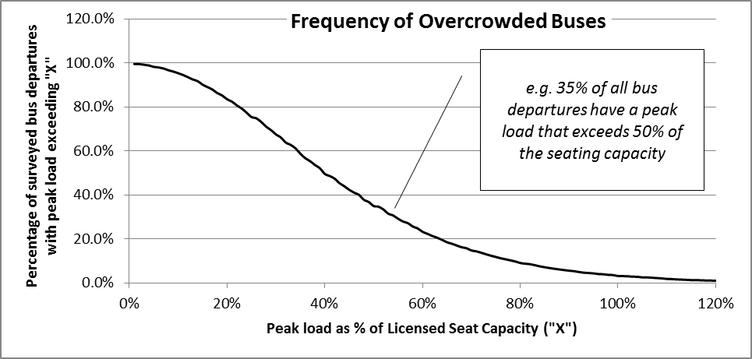

**Figure 1 Frequency of bus departures at different peak loads**

The data shows, for example, that 35% of bus departures have a peak load which exceeds 50% of the licensed seating capacity – or conversely, that 65% of bus departures are never more than half full. The data shows that the overall proportion of “crowded” bus departures, as identified by having a peak load of passengers in the region of the nominal seating capacity, is very small. Only 7% of all bus departures have a peak load which exceeds 85% of the seating capacity.

The curve shown in Figure 1 provides a snapshot of how operators have responded to the varying levels of demand by time of day, day of year and across the network, given the overall level of passenger demand. Consequently, the observed proportion of crowded buses represents a de-facto measure of how operators choose to trade-off the commercial necessity of achieving acceptable overall load factors, against passenger discomfort and potential loss of commercial revenue from overcrowded buses. The curve can therefore be regarded as a “revealed” summary of the operators’ planning policies, as applied to current (2009-10) travel patterns.

**The influence of generated concessionary passengers on crowding**

The “tail” of the frequency distribution to the right of Figure 1 represents the proportions of bus departures which are relatively crowded, for example as represented in the 7% of peak loads that exceed 85% of the seat capacity. There is no reason to doubt that the observed frequency distribution does not represent an equilibrium situation which operators would seek to regain in the event of a change in demand. Fewer passengers would result in a reduction in the number of crowded buses, whereas more passengers would lead to an increase in crowded buses. It therefore seems reasonable to suppose that the operator response to a change in demand would be to adjust their service levels to get back to the observed 7% level of crowding.

The Nexus data allows the passengers on board each surveyed bus, at the peak load point, to be broken down by passenger type, including older and disabled concessionary passengers. Assuming that the proportions of generated and non-generated concessionary passengers are uniformly distributed, it is therefore possible to simulate the situation of there being no generated concessionary passengers by applying a Reimbursement Factor to the passengers at the peak load point on each surveyed bus.

Figure 2 shows a more detailed picture of the “tail” of the distribution i.e. the frequency with which buses are crowded:

* The solid line is the observed frequency of bus departures at different crowding levels;
* the dashed line shows the frequency of different crowding levels that would be observed if the surveyed numbers of older and disabled concessionary passengers were reduced to simulate a situation in which there were no generated passengers.

The Reimbursement Factor used for this simulation is 50%, which is a fairly typical value of the allowance made for generated concessionary passengers. Results seem relatively insensitive to the Reimbursement Factor adopted. Older and disabled concessionary passengers represent about 35% of the total number of passengers on the included bus departures, so the total number of passengers would fall by about 18% if generated concessionary passengers were not carried.

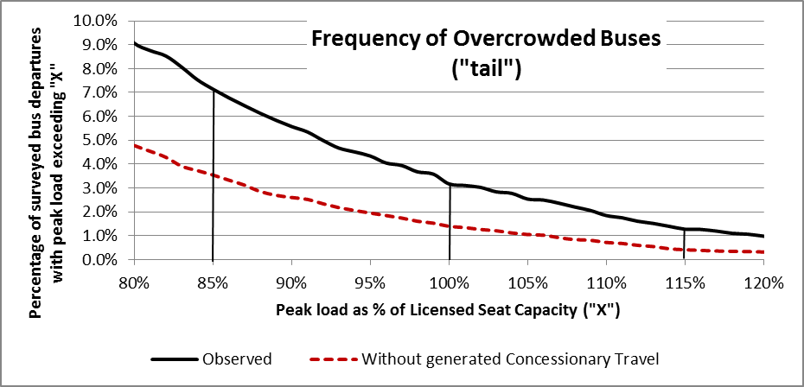

**Figure 2 Tail of distribution with and without generated concessionary passengers**

It can be seen that the number of crowded buses falls:

* from 7.1% to about 3.5% if crowding is measured as a peak load in excess of 85% of the seating capacity;
* from 3.2% to 1.4% at 100% of the seating capacity
* from 1.3% to 0.4% of bus departures if crowding is measured as a peak load in excess of 115% of the seating capacity (which is still likely to be within the licensed capacity of most buses if standees are included).

Clearly, the lower the capacity threshold, then the bigger will be the difference between the proportions of crowded buses with and without generated concessionary passengers. The largest difference between the proportions of “crowded” buses is about 14%, and that is at a capacity threshold of 38%, representing a bus that is much less than half full, even at its most crowded point.

These differences in crowded bus proportions all reflect the impact of a reduction in total passenger numbers of 18%. The fact that the number of crowded buses is far less than proportional reflects the time and place at which peak loads occur, and the contribution of concessionary passengers to the peak loads. It suggests that on the whole, older and disabled concessionary passengers are not travelling when and where buses are most crowded, but rather are making use of the bus network when there is ample spare capacity.

On the basis of this evidence, the impact of concessionary passengers on crowding levels appears to be small, and consequently the likely additional costs associated with additional buses operated to accommodate them is also likely to be small.

**Putting Costs to Additional Bus Departures**

The results of the analysis of the 2009-10 CMS data illustrated above are summarised in Table 1. It gives the total number of bus departures analysed and identifies those departures for which the peak load exceeded 70%, 85% and 100% of the seating capacity of the surveyed bus.

|  |  |  |  |  |
| --- | --- | --- | --- | --- |
| Total number of analysed bus departures | 7,535 | | | |
| Of which with peak load exceeding % of seats | 70% | 85% | 100% | |
| Crowded buses with generated concessionary passengers | 1,113 | 538 | 239 | |
| (as % of total) | 14.8% | 7.1% | 3.2% | |
| Crowded buses without generated concessionary passengers (50% Reimbursement Factor Assumed) | 617 | 267 | 105 | |
| (as % of total) | 8.2% | 3.5% | 1.4% | |
| Difference in the number of crowded buses | 496 | 271 | 134 | |
| (as % of total) | 6.6% | 3.6% | 1.8% | |
| **Table 1 Summary of Analysed Bus Departures** | | | |

The data demonstrates that overall, the proportion of bus departures on which the peak load is anywhere near the licensed seating capacity is relatively small. 3.2% of bus departures have a peak load which exceeds the seating capacity, even though the physical capacity of most buses, as measured by the combination of maximum seating and standing passengers, probably exceeds the seating capacity by at least 15% (i.e. a capacity threshold of 115%). At the other extreme, fewer than 15% of bus departures have a peak load which exceeds 70% of the seating capacity.

The difference in the number of crowded buses with and without generated passengers is taken to be a measure of the buses that would not be operated if there were no concessionary passengers. The ITS work for DfT has identified distance and time-based unit costs for operating buses which can be used to calculate the cost of operating the additional bus departures. This requires estimates of the average distance and speeds of bus operations. The values used here, are summarised in Table 2, which are based on analysis of operational characteristics captured by CMS, with the exception of data provided by one major operator whose network characteristics may not be accurately reflected in the available CMS data.

|  |  |
| --- | --- |
| Cost per vehicle hour (£) 2009-10 prices | £13.3000 |
| Cost per bus mile (£) 2009-10 prices | £0.6100 |
| Route Length (miles) | 10.12 |
| Speed (miles per hour) | 10.45 |
| Implied vehicle hours per bus departure | 0.97 |
| Cost per departure | £19.07 |
| **Table 2 Costs per bus departure** | |

These unit costs allow the cost of additional bus departures to be calculated. In themselves, as absolute values, these are not easy to interpret. However, they can be related to the measures of additional costs calculated using DfT Guidance by converting to an average cost per generated passenger. An alternative way of interpreting the data is by relating the implied change in buses operated to the change in passenger numbers, which gives what is known as the Mohring Factor. DfT Guidance recommends use of a Mohring Factor of 0.6. which implies that a 10% change in passengers would lead to a 6% change in bus departures. The calculation of these various measures is set out in Table 3.

|  |  |  |  |  |
| --- | --- | --- | --- | --- |
| **Data for calculation of Indicators** | **All Bus Operators** | | | |
| Average cost per departure | £19.07 | | | |
| Passenger numbers with generated passengers | 233,945 | | | |
| Passenger numbers without generated passengers | 192,484 | | | |
| Estimated generated passengers | 41,461 | | | |
| Generated passengers as % of total | 21.5% | | | |
| Capacity threshold as % of seating capacity | 70% | 85% | 100% | |
| Additional bus departures | 496 | 271 | 134 | |
| Gross cost of additional bus departures | £9,456.69 | £5,166.86 | £2,554.83 | |
| **Gross cost per generated passenger (2009-10 prices)** | **£0.228** | **£0.125** | **£0.062** | |
| Additional bus departures as % of total | 6.6% | 3.6% | 1.8% | |
| **Mohring Factor** | **0.306** | **0.167** | **0.073** | |
| **Table 3 Additional Capacity Cost Indicators** | | | |

The passenger numbers are calculated directly from CMS data, using the same set of surveyed bus departures as the analysis of peak loads. The peak load analysis implies that generated concessionary passengers require the operation of 271 departures at an 85% capacity threshold which would cost about £5,200 in additional capacity costs. The average capacity cost per generated passenger would therefore be 12.5 pence in 2009-10 prices at an 85% capacity threshold. A higher threshold implies a lower cost per generated passenger, and a lower threshold a higher cost per generated passenger.

The Mohring Factor, for which DfT recommends a value of 0.6, can be calculated by dividing the additional bus departures inferred to be necessary to maintain observed levels of crowding, by the percentage change in demand represented by generated passengers. For example, the Mohring Factor if measured at an 85% capacity threshold is 3.6% divided by 21.5% or 0.167. As can be seen, the resulting values are significantly lower than DfT’s recommended value. Even at a 70% capacity threshold the calculated value is half that recommended by DfT, at 0.306.

**Deducting Revenue Gains from Gross Additional Capacity Costs**

The additional costs shown in Table 3 represent gross capacity costs: they are the additional capacity costs associated with the operation of a number of additional bus departures to accommodate generated concessionary passengers. The operation of additional bus departures will improve the attractiveness of the bus service, and as a consequence will increase commercial revenues from non-generated passengers. These additional revenues will offset the additional costs associated with the additional departures.

DfT recommends that a service elasticity of 0.66 is used to estimate the change in demand arising from the supply of additional capacity. The average revenue per non-generated passenger is assumed to be £1.32, based on an average cash fare (in 2009-10) of £1.55, to which a discount factor of 15% has been applied. The total additional revenue that is estimated using these assumptions more than outweighs the additional costs of operating the additional buses – more revenue is generated than the associated operating costs. The calculations are summarised in Table 4.

|  |  |  |  |
| --- | --- | --- | --- |
| Service elasticity | £0.660 | | |
| Number of non-generated passengers | 192,484 | | |
| Average fare | £1.320 | | |
| Capacity threshold | 70% | 85% | 100% |
| Change in service levels (bus departures) | 6.6% | 3.6% | 1.8% |
| Change in demand from changed service | 4.4% | 2.4% | 1.2% |
| Change in revenue | £11,161.97 | £7,137.07 | £3,517.92 |
| Gross change in capacity costs | £9,456.69 | £5,166.86 | £2,554.83 |
| Net change in capacity costs | -£1,705.28 | -£1,970.21 | -£963.09 |
| Net change in costs per generated passenger | -£0.04 | -£0.05 | -£0.02 |
| **Table 4 Net capacity costs after allowing for generated revenue** | | | |

Looking at the calculations using a 70% capacity threshold, the 6.6% change in service departures associated with accommodating generated concessionary passengers is estimated to lead to a 4.4% change in non-generated passengers, which would give a change in fare revenue of £11,160. This is £1,705 more than the gross change in capacity costs – implying that overall there would be a commercial gain to the operator as a result of operating additional services to accommodate generated concessionary passengers. This outcome is identical irrespective of the capacity threshold selected, although the gap between gross costs and additional revenue narrows at the higher capacity thresholds.

In principle, the potential demand-generating effects of additional buses require further adjustment to allow for the additional marginal costs associated with carrying passengers generated by additional service. This would have the effect of reducing the net change in costs per generated costs by the order of 10% (i.e. about a penny per generated passenger), but does not change the overall conclusion.

It therefore seems that there is little case for the payment of bus operators for additional capacity costs, even if quite generous assumptions were adopted with regard to capacity thresholds.

**Caveats**

There are inevitably a number of caveats that need to be applied to these results.

*Use of unexpanded data*

The reported figures are all based on analysis of unexpanded data on sampled bus journeys, and make no attempt to expand the results to reflect, for example, annual totals of additional bus journeys operated. In itself this should have no impact on the accuracy of the proportions of buses observed at different levels of crowding, and the measures of additional capacity cost calculated from them. However, both CMS sampling strategies, and the need to exclude incomplete and cross-boundary services, may mean that the results are not as fully representative of the generality of bus services in Tyne and Wear as would be wished.

It is not possible to fully replicate the expansion process use by Nexus in order to produce County-wide estimates of passenger numbers etc. However, cruder expansion methods have been developed using annual estimates of bus departures by hour and day of week. These do not suggest that in broad terms the results quoted on an unexpanded basis would be significantly different if full expansion was applied.

*Application to individual operators*

The reported results make use of data for all operators. It is quite possible to carry out identical analysis for the data from individual operators. However, for smaller operators the results will be increasingly subject to sample error, because the absolute number of bus departures identified as “crowded” will be quite small. Even for the third largest operator in Tyne and Wear, the absolute number of such observations is less than 50, and it is difficult to be confident that these small numbers of individual observations are fully representative of the entirety of the operator’s network. This concern is compounded by the likelihood that the mix of internal and cross-boundary routes operated by individual operators is such that the journeys available for analysis will be properly representative of their serviecs.

Consequently, analysis of data for most individual operators may not give reliable results. More robust results would arise from analysis of data for the two largest operators, but this has not yet been carried out.

*Sensitivity to input assumptions*

The most significant assumption necessary for the analysis is the Reimbursement Factor, which is applied to the observed older and disabled concessionary passengers on each surveyed journey in order to determine the peak load if there were no generated concessionary passengers. Results seem to be relatively insensitive to the value assumed, with little difference if a Reimbursement Factor of 40% is applied as opposed to the 50% used in the reported analysis.

There is an implicit assumption that generated passengers will be evenly distributed, and in particular the same proportion of concessionary passengers are generated on both crowded and less crowded services. It is possible to argue that passholders using the concession for work-related journeys will be both less likely to be generated, and will be more likely to travel at crowded times. On the other hand, the majority of passholders are likely to prefer not to travel at crowded times, and in the absence of any evidence to the contrary, an assumption that generated travel is evenly distributed is regarded as being the most neutral.

The analysis of revenue impacts from additional capacity relies upon both an assumption of service elasticities and the average fare. The service elasticity has been taken as that recommended by DfT, and does not reflect any local evidence. However, the average fare paid by non-generated passengers does reflect CMS data. It should be noted that a lower fare is more likely to result in higher net capacity costs (i.e. is in the operator’s favour with regard to additional cost reimbursement), but is likely to have a larger negative impact on revenue forgone payments. The value adopted in the analysis reported here, which assumes a substantial discount, is therefore more likely to result in positive additional capacity costs. Because it turns out that net additional capacity costs are negative even with quite favourable assumptions, detailed assessment of the average fare has not been carried out. Further analysis would almost certainly confirm the overall conclusions of the work.

**Conclusions**

As discussed above, the estimation of additional capacity costs that might arise from generated concessionary passengers requires speculation about how operators match the supply of bus services to demand. In a different regulatory environment, explicit planning policies might set out operators’ objectives with regard to matching supply to demand, but these are not available in the current context.

The analysis described here therefore seeks to infer operators’ *de facto* planning policies by observing the relationship between supply and demand, as represented by the frequency distribution of the peak load of passengers on individual bus departures relative to the licensed seating capacity of each bus. The assumption is made that, broadly, bus operators will seek to maximise average load factors, but within the constraint of limiting the proportion of crowded buses to an acceptable maximum.

Nexus data suggests that in 2009-10, operator policies were such that 3.2% of bus departures had a maximum load that exceeded 100% of the seating capacity, 7.1% exceeded 85% of the seating capacity, and 14.8% exceeded 70% of the seating capacity of the individual buses on which the maximum load was measured.

These figures reflect the observed situation, with operators carrying generated concessionary passengers. If the same buses were operated but there had not been a concessionary scheme, fewer buses would have been crowded, and these proportions would have fallen to 1.4%, 3.5% and 8.2% respectively. It is proposed that in the counterfactual situation, operators would have reduced service levels in order to maintain the proportions of crowded buses actually observed. The difference between the number of crowded buses “with” and “without” generated concessionary passengers therefore represents a measure of the additional service that operators provide in order to accommodate generated concessionary passengers.

The additional capacity cost associated with these additional bus departures has been estimated by reference to DfT recommended unit costs. In 2009-10 prices and expressed as a cost per generated concessionary passenger, these range from 6.2 pence at a 100% capacity threshold, to 12.5 pence at an 85% capacity threshold, and 22.8 pence per generated passengers at a 70% capacity threshold. But in all cases, the additional revenue that would arise from non-generated passengers as a consequence of additional service exceeds the additional costs – in other words, there was a net commercial benefit from operating the additional buses, and the operator would not be financially worse off as a consequence.

Consequently, there is no case for payment of reimbursement for additional capacity costs.

Andrew Last, Minnerva Ltd

15th April 2011